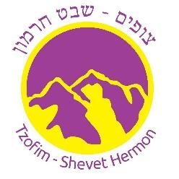

Volunteer Letter

This letter confirms that) name of applicant)
Click or tap here to enter text.
Contributes her time as a volunteer at Tzofim- Shevet Hermon Inc. (Israeli Scouts of Toronto - Chapter Hermon). There is no remuneration of payment of any kind for these volunteer services.

The reason for which this Vulnerable Sector Police Check is required is that the above person will be volunteering with children during our chapter activities and on trips/camps during the year.

Yours truly
TZOFIM – SHEVET HERMON INC.
Corporation no. 999015-1
hermon@israelscouts.org

